Enforcement & Compliance History Online (ECHO)
Data is frozen (locked), depending on state while they are migrating to a new system. ECHO is used to get data from the PCS system. PCS has the NDPES DMR Data that was submitted by the facility (i.e. the data from the printed NPDES DMR Report).
To search for a facility (find it’s permit number,etc..)
http://www.epa-echo.gov/echo/compliance_report_water_icp.html
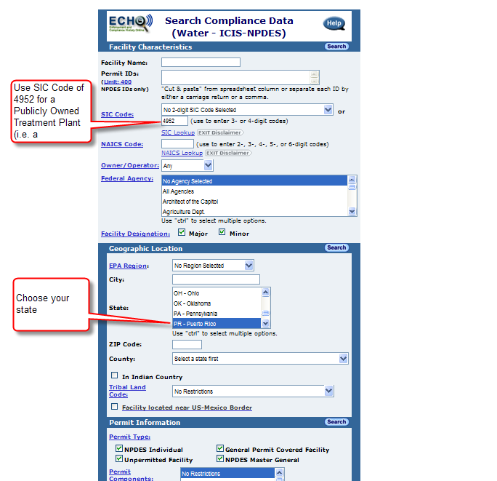

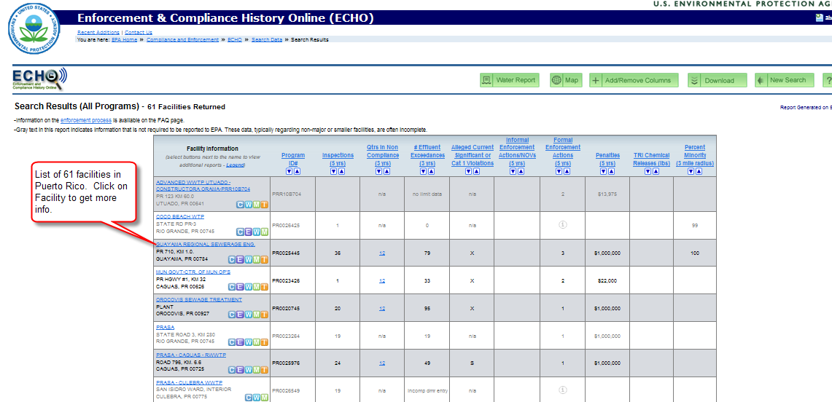

To lookup data for a facility http://www.epa.gov/enviro/facts/pcs/customized.html
To get historical data, choose Effluent Measurements/Violations
